# Intel Unnati Industrial Training Program 2024

# **Project Report**

# **On**

# *PS-02 Integrated Common Services to Common People*

Bachelor of Technology

*Computer Science & Design*

Under the guidance of

*Mr. Debdyut Hazra*

Submitted By: -

Saloni Kumari

[saloniisingh9782@gmail.com](mailto:saloniisingh9782@gmail.com)

DEPARTMENT OF SCIENCE AND TECHNOLOGY

World college of Technology and Management,

Farrukh Nagar

Acknowledgement

I would like to express my sincere thanks and gratitude to Intel Team for providing me this

great opportunity to showcase my skills. I also like to express my deepest appreciation to Mr. Debdyut Hazra, who provided me with the valuable guidance and advice throughout the preparation of this project. Their insightful feedback and continuous support have been instrumental in shaping this work.

I am also grateful to Dr. Preeti, World college of Technology and Management, for providing me with necessary resources and facilities to carry out this project.

Furthermore, I extend my thanks to my family and friends for their encouragement

and understanding during this academic endeavour.

*Saloni Kumari*

ABSTRACT

Problem Statement –

* + - *Integrated Common Services to Common People*

*Education*:

Learning materials, online Mentors, students, teachers etc.

School details and admission window with fee structures

Second hand / reusable learning materials for lesser cost including laptops etc.

Nearest tuition centre for a particular subject, with teacher details.

Details on Arts, music, sports and cultural activity centres.

Industry training and job aid centres.

Developing a GUI web application through which all the services should be available for a common man who can access this through mobile phones. Both service user and service provider should register & authenticate to avail the services.

Problem Solution –

Let’s envision “Wiser”, a web application designed to provide a comprehensive platform for educational resources, including information on colleges, online classes, tutors and study materials.

Wiser aims to provide a user- friendly and comprehensive platform for students and learners seeking educational resources, whether it’s information about colleges, online classes, tutors, or study materials.

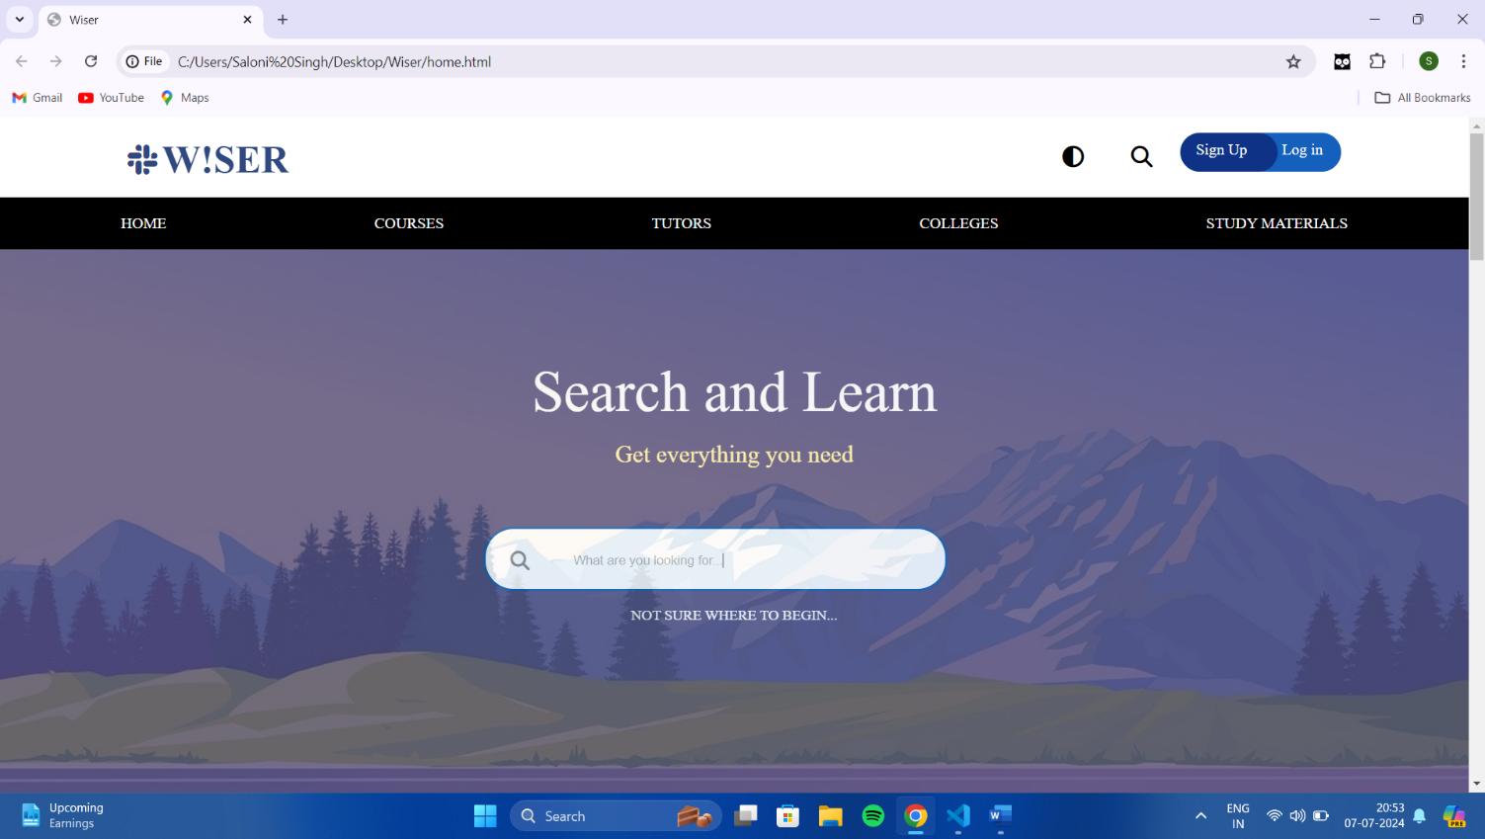

TABLE OF CONTENTS

**1 Introduction 5**

1.1 Problem Statement 5

1.2 Project Objectives 5

1.3 Project Scope 6

**2 Literature Review 7**

2.1 Overview of Educational Applications 7

2.2 The Role of Wiser in Education 7

**3. Requirement Analysis 8**

3.1 Functional Requirements 8

3.2 Non-functional Requirements 9

**4. System Design 10**

**4**.1 High level architecture 10

4.2 System Design 11

4.2.1 Sitemap 11

4.2.2 State Chart Diagram 11

4.2.3 Sequence Diagram 12

**Future Enhancements 13**

**Conclusion 14**

**Bibliography 15**

1. Introduction

**1.1 Problem Statement**

Developing a GUI web application through which all the services should be available for a common man who can access this through mobile phones. Both service user and service provider should register & authenticate to avail the services.

**1.2 Project Objectives**

*“The purpose of Wiser is to provide all the information user needs.”*

The main objective of developing wiser can be summarized as follows:

1. **Centralized Learning Hub**: Create a centralized platform where students can access study materials for various subjects and levels.

2. **Online Tuition Services:** Offer online tutoring services where students can connect with tutors for one-on-one sessions or group classes. This may include scheduling, payment processing, and video conferencing capabilities.

3**. Comprehensive Information**: Provide detailed information about tutors available on the platform, including their qualifications, areas of expertise, and reviews from past students.

4**. College Information**: Offer insights into different colleges and universities, including admission requirements, courses offered, faculty information, campus facilities, and student testimonials.

5**. User-Friendly Interface**: Design an intuitive and user-friendly interface that allows easy navigation between different sections such as study materials, tutor profiles, and college information.

6. **Personalization:** Implement features that allow students to personalize their learning experience based on their academic needs and preferences. This could include recommended study materials or tutors based on their interests and past interactions.

7. **Community Engagement**: Foster a community environment where students, tutors, and educational institutions can interact, share resources, and participate in forums or

discussion boards related to various subjects or academic interests.

8. **Accessibility and Mobile Compatibility**: Ensure that the web page is accessible across different devices (desktops, tablets, smartphones) and compatible with various operating systems to cater to a wide audience.

9. **Security and Privacy**: Implement robust security measures to protect user data, ensure secure transactions, and maintain privacy standards in accordance with relevant regulations.

10. **Continuous Improvement**: Gather feedback from users to continuously improve the platform's features, content offerings, and overall user experience.

By focusing on these objectives, Wiser serves as a valuable resource for students seeking educational support, tutoring services, and information about colleges and universities.

**1.3 Project Scope**

The application Wiser will be useful for learners and students. With this application user can get all the specific details about tutors, online classes, and study materials likes notes, pdf etc. It will provide a user-friendly dashboard which will serve for all user needs. User can easily personalize their learning and save them.

**Scope:**

* Secure User authentication
* Search functionality
* Communication tools
* Content management
* User-friendly interface
* Responsive Design

2. Literature Review

In the realm of education and learning, technological advancements have revolutionized the way students access information, interact with learning materials, and engage with educators. The emergence of educational applications has played a pivotal role in facilitating personalized learning experiences and enhancing educational outcomes. One such innovative application poised to make a significant impact in the field is Wiser.

**2.1 Overview of Educational Applications**

Educational applications have become integral tools for both learners and educators in today's digital age. These applications offer a diverse range of functionalities aimed at supporting various aspects of the learning process, including accessing study materials, connecting with tutors, participating in online classes, and organizing educational resources. The proliferation of smartphones and tablets has further accelerated the adoption of these applications, making learning more accessible and convenient than ever before.

**2.2 The Role of Wiser in Education**

Wiser stands out as a comprehensive educational application designed to cater to the diverse needs of learners and students. At its core, Wiser aims to provide users with a seamless and user-friendly interface. Wiser represent a valuable tool for learners and students seeking to enhance their educational experiences. By providing access to a diverse range of learning resources, supporting personalized learning journeys, and fostering collaborative interactions, these applications play a pivotal role in transforming traditional learning paradigms.

3. Requirement Analysis

### **3.1 Functional Requirements:**

1. **User Registration and Authentication:**

* Users should be able to create accounts and log in securely.
* User authentication should be robust to protect personal data.

1. **Dashboard:**
   * A user-friendly dashboard that displays personalized content based on user preferences and history.
   * Sections for upcoming classes, saved materials, and recommended tutors.
2. **Tutor Search and Profiles:**
   * Search functionality to find tutors based on subject, availability, ratings, etc.
   * Detailed profiles for each tutor including qualifications, reviews, and schedules.
3. **Online Classes:**
   * Integration with online class platforms or hosting classes directly within the app.
   * Schedule management for users to view and attend classes.
4. **Study Materials:**
   * Central repository for study materials such as notes, PDFs, videos, and quizzes.
   * Organized by subject and topic for easy navigation and access.
5. **Personalization:**
   * Ability for users to customize their learning experience.
   * Save favourite tutors, bookmark study materials, and set learning goals.
6. **Notifications:**
   * Alerts for upcoming classes, new study materials, and messages from tutors.
   * Customizable notification settings.

### **3.2 Non-functional Requirements**:

**1. Performance:**

* + Fast loading times for dashboards and study materials.
  + Scalability to handle a growing user base and increasing data volume.

1. **Security:**
   * Secure data storage and transmission.
   * Compliance with data protection regulations (e.g., GDPR, CCPA).
2. **User Interface:**
   * Intuitive and user-friendly interface across web and mobile platforms.
   * Accessibility features to accommodate all users.
3. **Reliability:**
   * Minimal downtime and reliable service availability.
   * Regular backups and disaster recovery plan.
4. **Integration:**
   * Seamless integration with external services (e.g., payment gateways for tutor payments).
5. **Support:**
   * Help desk or customer support for user queries and technical issues.
   * FAQ section and user guides within the app.

4. System Design

### **4.1 High level architecture**

The high-level architecture of the "Wiser" application can be conceptualized as follows, focusing on its major components and their interactions

### **Components of High-Level Architecture:**

1. **Client-Side Application:**
   * **User Interface (UI):** Provides a responsive and intuitive interface for users (learners and students) to interact with the application.
   * **Dashboard:** Centralized area where users can access personalized content, manage their learning activities, and interact with various features of the application.
2. **Server-Side Application:**
   * **Application Server**: Handles the core business logic of the application, including user management, tutor management, class scheduling, and content delivery.
   * **API Layer**: Facilitates communication between the client-side application and the server-side components. This includes authentication, data retrieval, and interaction with external services.
3. **Database:**
   * Relational Database: Stores persistent data such as user profiles, tutor profiles, class schedules, study materials (notes, PDFs), user preferences, and transactional data. Examples include MySQL.
4. **External Integrations:**
   * **Online Class Platforms:** Integration with third-party platforms or APIs for hosting online classes or virtual classrooms.
   * **Content Providers**: Integration with services that provide study materials such as notes, PDFs, videos, and quizzes.
5. **Supporting Services:**
   * **Authentication and Authorization**: Ensures secure access control to the application and its resources.
   * **Notification Services:** Sends notifications to users for class reminders, updates on study materials, and other relevant information.
   * **Analytics and Monitoring:** Tracks application usage, performance metrics, and user behaviour to improve service delivery.

**4.2 System Design**

**4.2.1 Sitemap:**

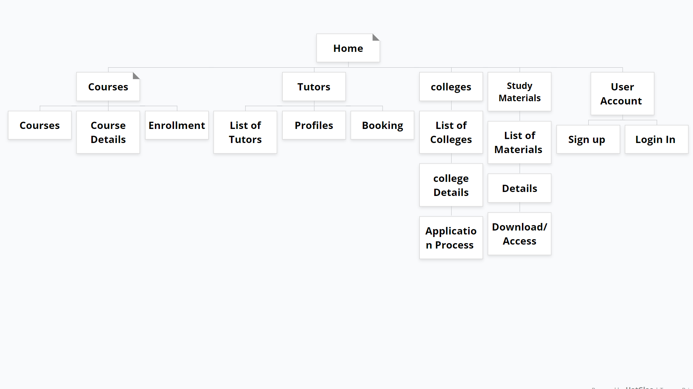

**4.2.2 State Chart Diagram:**

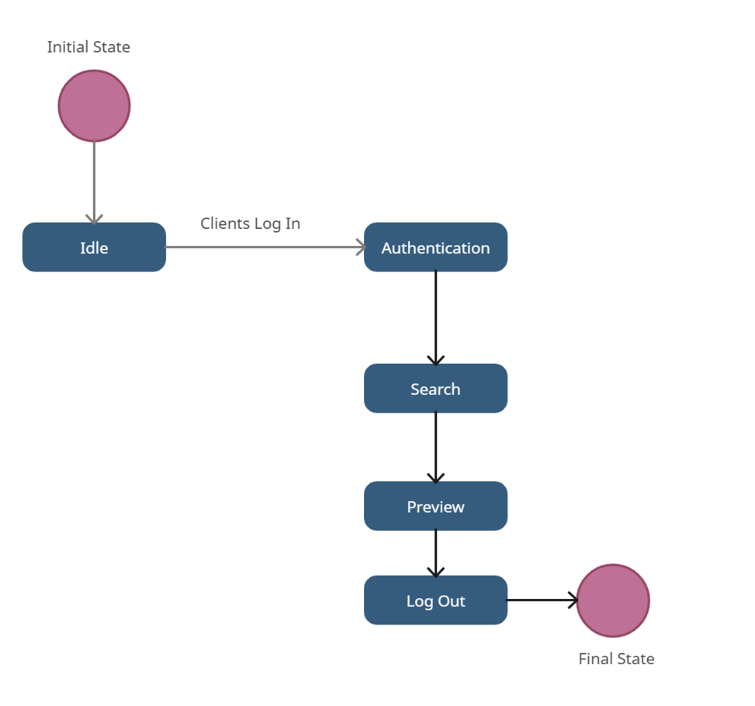

**4.2.3 Sequence Diagram:**

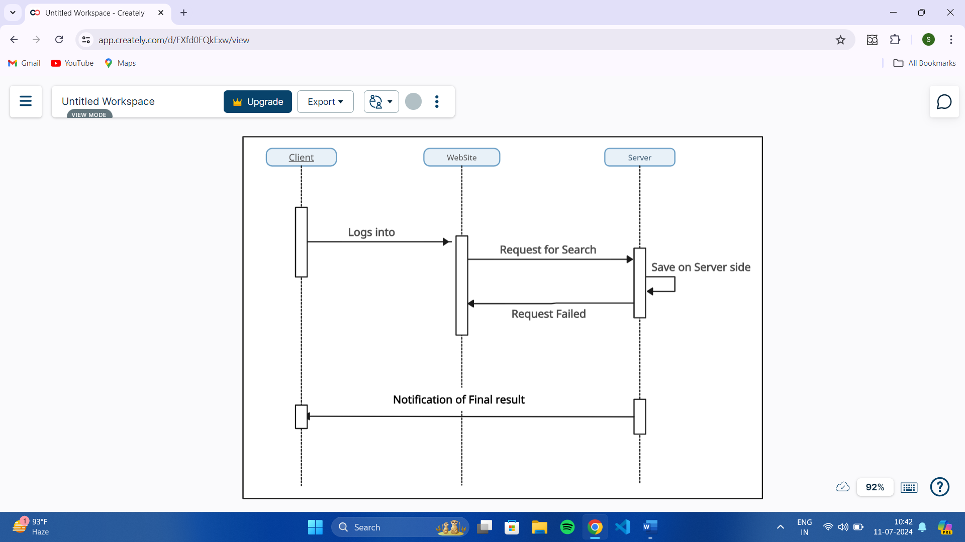

**Future Enhancements -**

1. **Interactive Features:**
   * Implement interactive quizzes and practice tests to help users gauge their understanding.
   * Introduce discussion forums and chat features for peer-to-peer learning and support.
2. **Advanced Analytics:**
   * Provide detailed analytics on learning progress and performance.
   * Offer insights and personalized recommendations to improve study habits and outcomes.
3. **Integration with Other Learning Platforms:**
   * Enable seamless integration with other popular educational tools and platforms.
   * Allow users to import/export study materials and sync schedules.
4. **Mobile App Development:**
   * Develop a dedicated mobile app for on-the-go access to all features.
   * Ensure cross-platform compatibility for a consistent user experience.
5. **Gamification:**
   * Introduce gamified elements like badges, rewards, and leaderboards to motivate users.
   * Create challenges and achievements to encourage consistent learning and engagement.
6. **Enhanced Security:**
   * Implement robust security measures to protect user data and privacy.
   * Ensure secure payment gateways for any transactions within the app.

Wiser aims to be the go-to platform for learners and students, providing a seamless and enriching educational experience.

**Conclusion -**

Wiser is poised to revolutionize the way learners and students approach their education by providing a comprehensive, user-friendly platform that caters to all their academic needs. With features that offer detailed tutor information, easy access to online classes, and a wealth of study materials, Wiser ensures a personalized and efficient learning experience. The intuitive dashboard and customization options further enhance user engagement and satisfaction.

Looking ahead, Wiser's planned future enhancements, such as interactive features, advanced analytics, and integration with other learning platforms, will solidify its position as an essential educational tool. The development of a mobile app and the introduction of gamified elements will make learning more accessible and enjoyable, while robust security measures will protect user data and ensure safe transactions.

In essence, Wiser is more than just an educational app—it's a comprehensive learning ecosystem designed to empower users to achieve their academic goals and foster a love for learning.

**Bibliography-**

**[1]** From Wikipedia, “ HTML”

<https://en.wikipedia.org/wiki/HTML>

[2] From Google, “ HTML” “ CSS”

<https://www.google.com/search?q=html+css>

[3] From W3schools, “JavaScript”

<https://www.w3schools.com/js/default.asp>

[4] From geeksforgeeks

<https://www.geeksforgeeks.org/html-javascript/?ref=gcse_ind>